The methods
- Disassembled the oven frame, exposed the fiber glass, extracted the fiber glass insulation layer from the oven, and Extracted the PTC heaters and rotary switches of the oven.
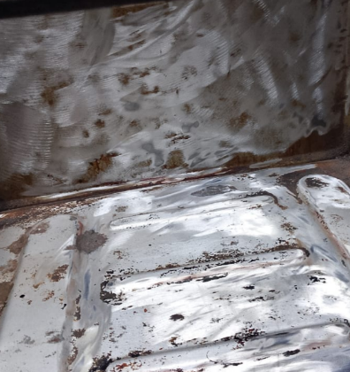
- Removed non-essential components remaining in the oven, cleaned the empty frame of the oven of left over residue as shown in Figure 1.
- Extracted the power supply from the PC to extract the capacitor, wires and the variable resistance.
- Extracted the rectifier bridge, a capacitor, and the acrylic from the mini fridge.
- The Thermostat was extracted from a home AC unit, and the transformer 16V 10A was extracted from the oven while the 12V 1A transformer was extracted from an old radio.
Figure 1: cleaned the empty frame of the oven
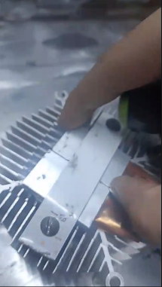
- Connected the transformer with the capacitor and the bridge to soften the direct current, put the heat sink in the oven, and the fan.
- Put the heater plates on the side of heat sink, as shown in Figure 2, and the thermoelectric on the back of the oven. Connected the thermostat to the prototype panel and connected silicon diodes on the PTC and thermoelectric cooler wires to the fan to adjust fan speed using variable resistance.
Figure 2: Put the heater plates on the side of heat sink
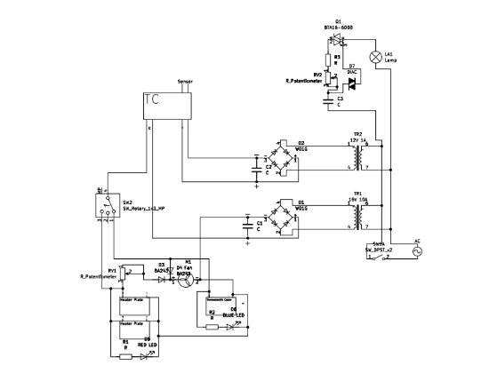
- Soldered a dimmer circuit from a capacitor, triac, diac, resistor, and variable resistance to control the light intensity, and connected it to an old potentiometer cap from the oven.
- Established a joint connection between one side of all components, connected the remaining sides to an old rotary switch from the oven.
- Connected the PTC and thermoelectric wires to the relay of the thermostat.
- Connected the heat circuit to the transformer output.
Figure 3: The MultiCubator circuit Schematic
- Completed the final connections of the circuit as shown in the schematic in figure 3

